Rooshan Naeem

SEECS-NUST

UPPAAL

UPPAAL- An integrated tool environment for modeling, validation and verification of real time systems modeled as timed automata.

UPPAAL assignment

Formal Methods

1. Simulation of light Model.

The light model has three states namely *dim, medium and bright*. Initially the device is in off state and pressing the button will change the state of the device to dim or bright depending on the type of button presses. There are two buttons namely *press and highButton.*

Pressing a press button on *off* state will take the device to *dim* state. Pressing the *highButton* will take the device to *Bright* state.

While on *dim* if button is pressed within 3 sec then it will move on to *medium* state, otherwise to *off* state again.

While on *medium* state pressing a button within 3 sec will turn on the *bright* state otherwise back to *dim* state.

On *Bright* state if button is pressed within 3 sec then it will take on *medium* state otherwise to *off* state.

**Below are the simulation screens**

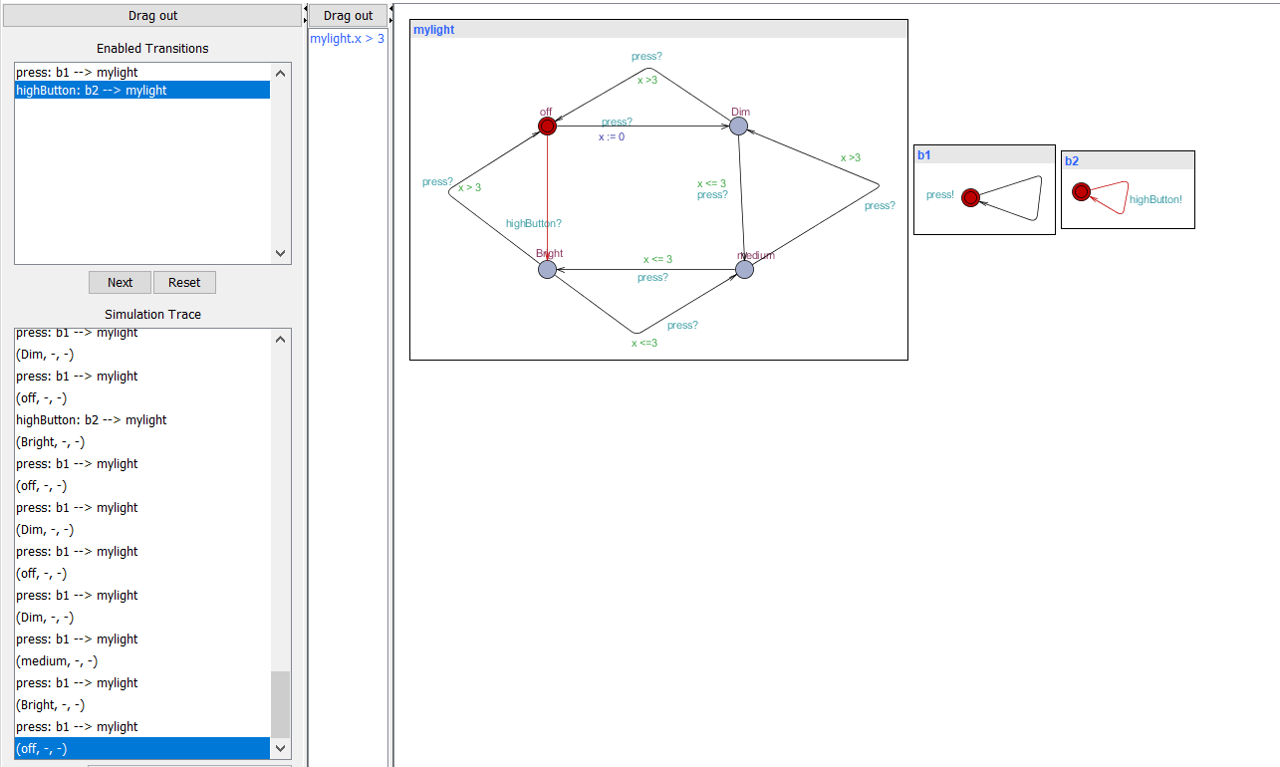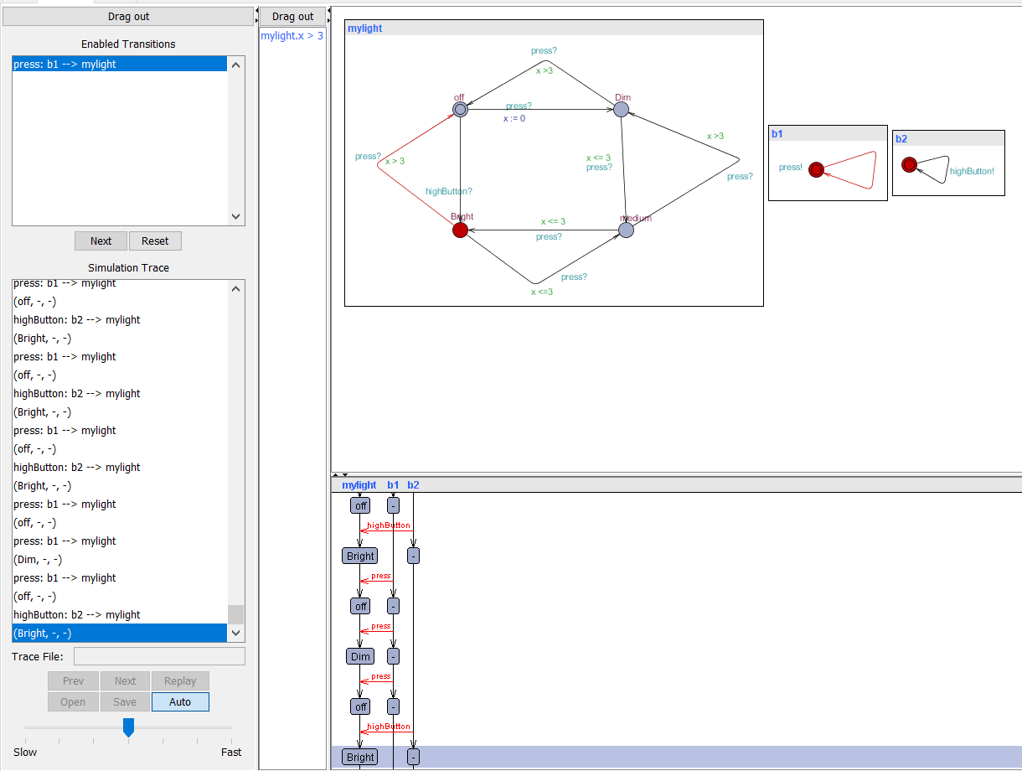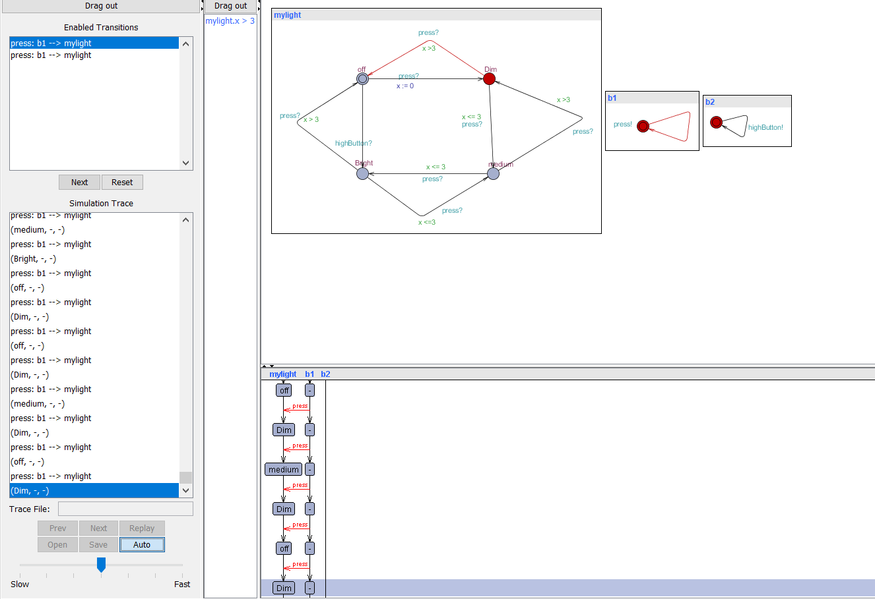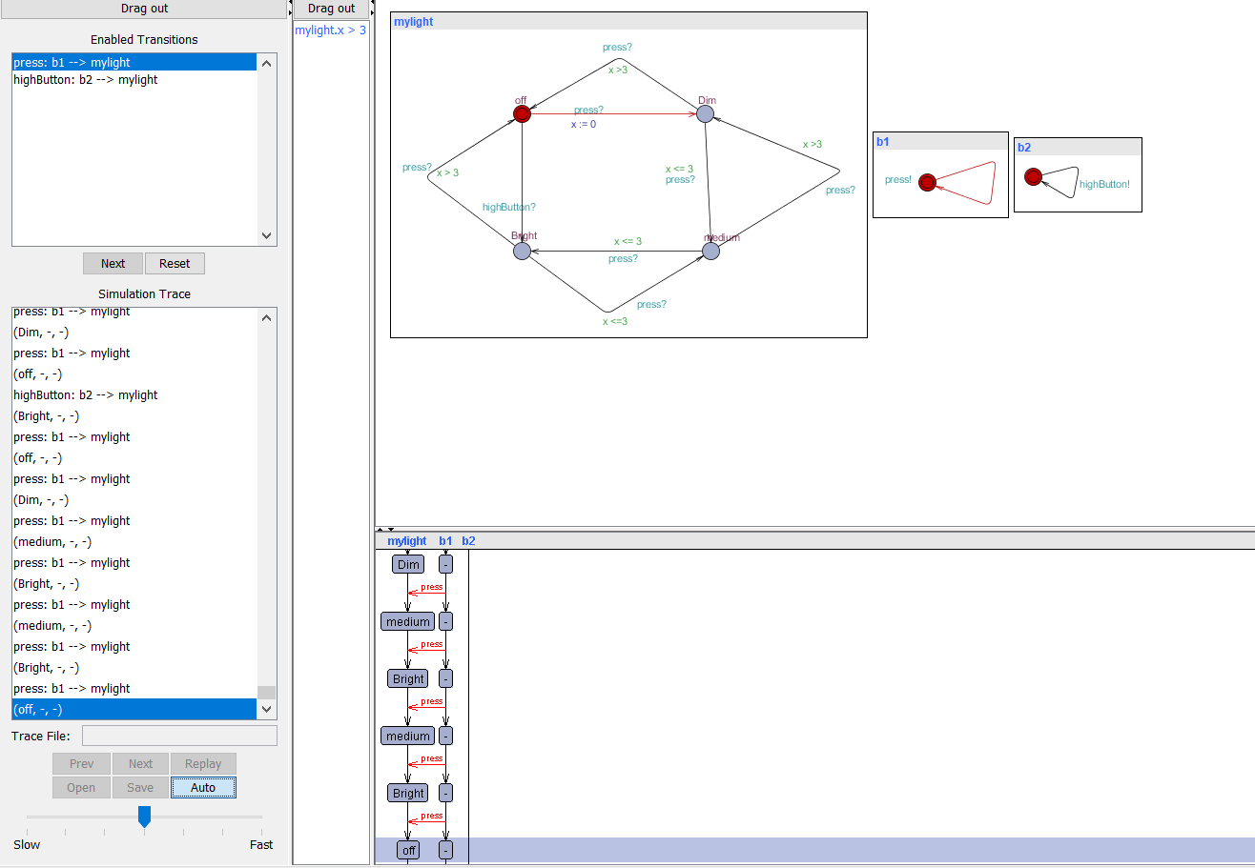

b) ATM Model Checker

There are 2 actors in this model namely customer and Bank and an ATM system.

This model is designed in such a way that transaction is only valid with bank balance greater than 10 euros.

Customer gets the cash when transaction is done.

Deadlock is prevented in this model.

In below model *ready* and *transaction_OK* implies that balance > 10

Below are the simulation screens.

